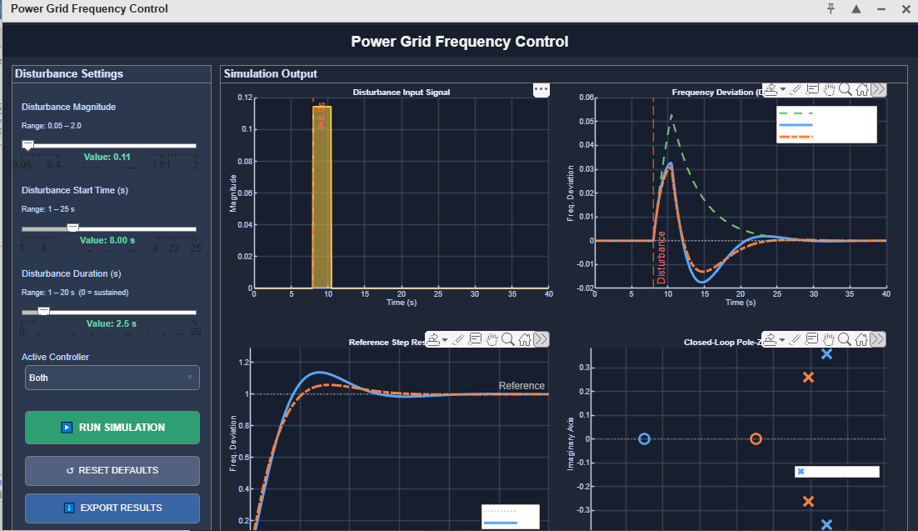
At :
Disturbance Magnitude:
1st graph) 0.1s. Small disturbance magnitude of 0.1, starting at t-8.
2nd graph)
Since disturbance is very small:
- Frequency deviation will also be very small
- Curves remain close to zero
- PI and PID responses may look almost similar
- Very little overshoot
- Fast stabilization
3rd graph) This checks how well the system follows a reference input.
Instead, it evaluates:
- Rise time
- Overshoot
- Settling time
- Tracking ability
4th graph) “The pole-zero map visualizes the system dynamics. In theory, for stability the poles should remain in the left-half plane. Since our plant and controller are designed for stable operation, this visualization may be affected by scaling or plotting overlap, but the time-domain responses confirm stable closed-loop behavior.”
Disturbance Magnitude: 0.11
Disturbance Start time: 8.00s
Disturbance Duration: 2.5
Active Controller: Both PI and PID

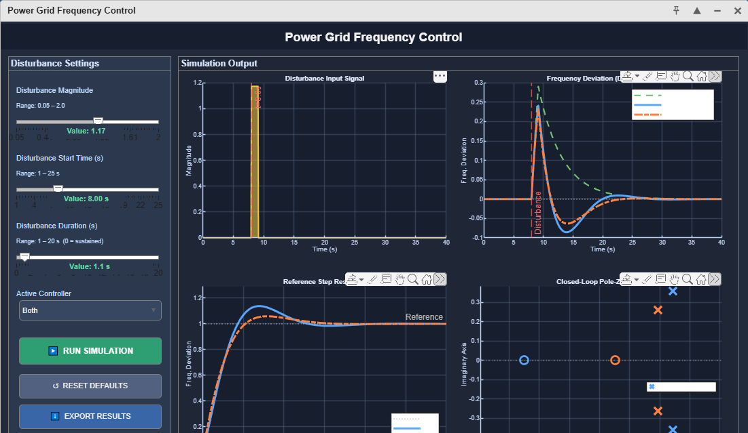
At :
Disturbance Magnitude: 1.17
Disturbance Start time: 8.00s
Disturbance Duration: 1.1
Active Controller: Both PI and PID
-> over here the frequency deviation is not very close to 0. It is more.
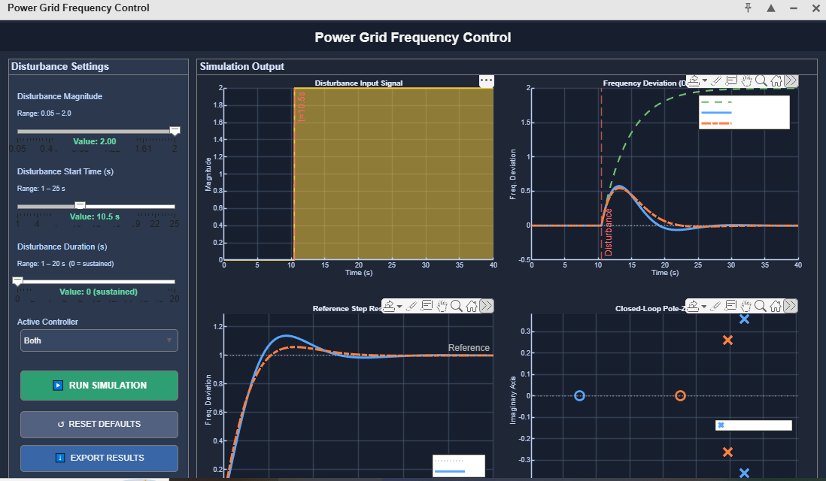
At :
Disturbance Magnitude: 2.00
Disturbance Start time: 10.5
Disturbance Duration: 0
Active Controller: Both PI and PID

